|  |  |
| --- | --- |
| A picture of a winding road and trees  Business Flow Plan | Solomon Morongwa Moshokoa: ST10229897  Bornwise Nkateko Baloyi: ST10105509  Roandiswa Mbedzi: ST10064879  Mokgadi Mamabolo: ST10204666  WORK INTEGRATED LEARNING  Group 3  DMT2 |

Table of content

**Intranet states gun-chat**

**WBS**

**Flow Plan**

**Topology diagram**

**Intranet states gun-chat**

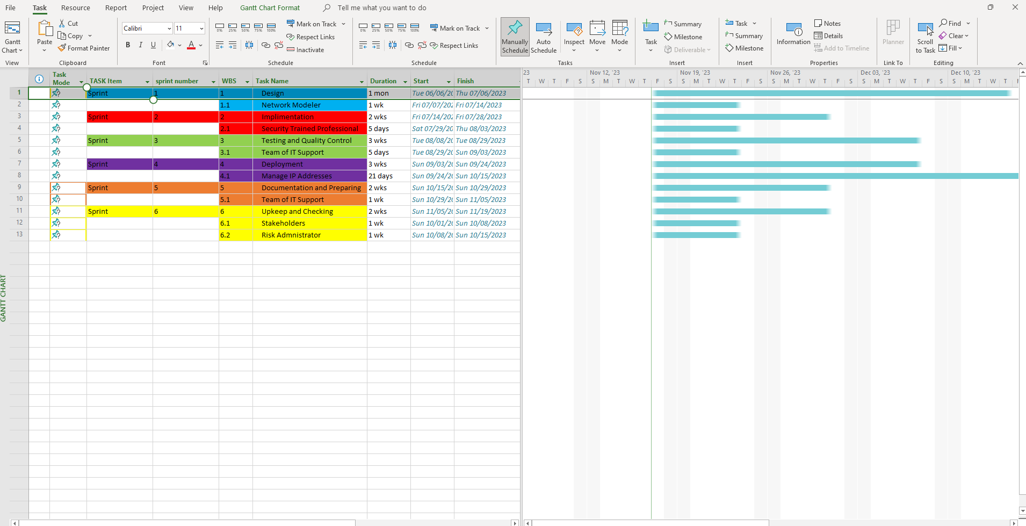

**WBS**

Flow Plan

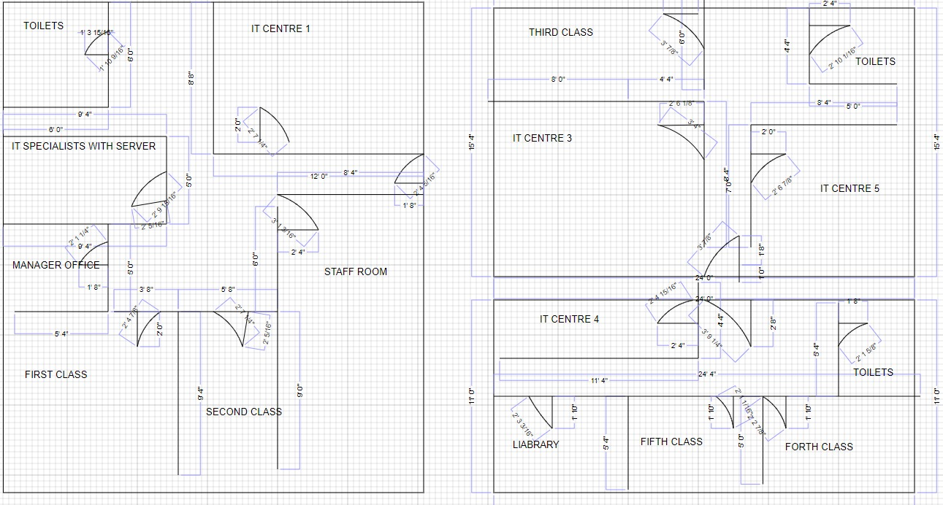

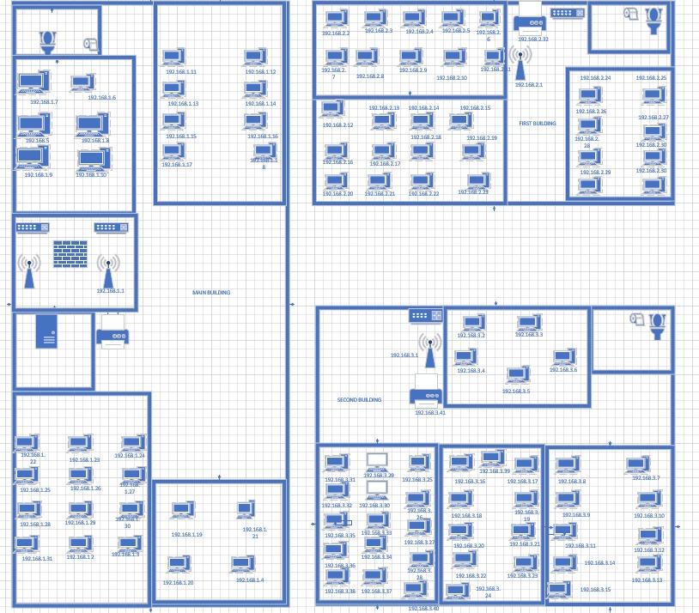

**Topology diagram**

# Network IP Addresses for Main building, building 1, building 2 and the lobby

**Main Building Subnet: 192.168.1.0/24**

|  |  |  |
| --- | --- | --- |
| **Building** | **Subnet** | **Device/Function** |
| Main Building | 192.168.1.1 | Wireless Access Point / Router |
| User 1 | 192.168.1.2 | Computer / PC |
| User 2 | 192.168.1.3 | Computer / PC |
| User 3 | 192.168.1.4 | Computer / PC |
| User 4 | 192.168.1.5 | Computer / PC |
| User 5 | 192.168.1.6 | Computer / PC |
| User 6 | 192.168.1.7 | Computer / PC |
| User 7 | 192.168.1.8 | Computer / PC |
| User 8 | 192.168.1.9 | Computer / PC |
| User 9 | 192.168.1.10 | Computer / PC |
| User 10 | 192.168.1.11 | Computer / PC |
| User 11 | 192.168.1.12 | Computer / PC |
| User 12 | 192.168.1.13 | Computer / PC |
| User 13 | 192.168.1.14 | Computer / PC |
| User 14 | 192.168.1.15 | Computer / PC |
| User 15 | 192.168.1.16 | Computer / PC |
| User 16 | 192.168.1.17 | Computer / PC |
| User 17 | 192.168.1.18 | Computer / PC |
| User 18 | 192.168.1.19 | Computer / PC |
| User 19 | 192.168.1.20 | Computer / PC |
| User 20 | 192.168.1.21 | Computer / PC |
| User 21 | 192.168.1.22 | Computer / PC |
| User 22 | 192.168.1.23 | Computer / PC |
| User 23 | 192.168.1.24 | Computer / PC |
| User 24 | 192.168.1.25 | Computer / PC |
| User 25 | 192.168.1.26 | Computer / PC |
| User 26 | 192.168.1.27 | Computer / PC |
| User 27 | 192.168.1.28 | Computer / PC |
| User 28 | 192.168.1.29 | Computer / PC |
| User 29 | 192.168.1.30 | Computer / PC |
| User 30 | 192.168.1.31 | Computer / PC |
| Printer | 192.168.1.32 | Printer |

# Building 1 Subnet: 192.168.2.0/24

|  |  |  |
| --- | --- | --- |
| **Building** | **Subnet** | **Device/Function** |
| Building 1 | 192.168.2.1 | Wireless Access Point |
| User 1 | 192.168.2.2 | Computer/PC |
| User 2 | 192.168.2.3 | Computer/PC |
| User 3 | 192.168.2.4 | Computer/PC |
| User 4 | 192.168.2.5 | Computer/PC |
| User 5 | 192.168.2.6 | Computer/PC |
| User 6 | 192.168.2.7 | Computer/PC |
| User 7 | 192.168.2.8 | Computer/PC |
| User 8 | 192.168.2.9 | Computer/PC |
| User 9 | 192.168.2.10 | Computer/PC |
| User 10 | 192.168.2.11 | Computer/PC |
| User 11 | 192.168.2.12 | Computer/PC |
| User 12 | 192.168.2.13 | Computer/PC |
| User 13 | 192.168.2.14 | Computer/PC |
| User 14 | 192.168.2.15 | Computer/PC |
| User 15 | 192.168.2.16 | Computer/PC |
| User 16 | 192.168.2.17 | Computer/PC |
| User 17 | 192.168.2.18 | Computer/PC |
| User 18 | 192.168.2.19 | Computer/PC |
| User 19 | 192.168.2.20 | Computer/PC |
| User 20 | 192.168.2.21 | Computer/PC |
| User 21 | 192.168.2.22 | Computer/PC |
| User 22 | 192.168.2.23 | Computer/PC |
| User 23 | 192.168.2.24 | Computer/PC |
| User 24 | 192.168.2.25 | Computer/PC |
| User 25 | 192.168.2.26 | Computer/PC |
| User 26 | 192.168.2.27 | Computer/PC |
| User 27 | 192.168.2.28 | Computer/PC |
| User 28 | 192.168.2.29 | Computer/PC |
| User 20 | 192.168.2.30 | Computer/PC |
| User 30 | 192.168.2.31 | Computer/PC |
| Printer | 192.168.2.32 | Printer |

# Building 2 Subnet: 192.168.3.0/24

|  |  |  |
| --- | --- | --- |
| **Building** | **Subnet** | **Device/function** |
| Building 1 | 192.168.3.1 | Wireless Access Point |
| User 1 | 192.168.3.2 | Laptop |
| User 2 | 192.168.3.3 | Laptop |
| User 3 | 192.168.3.4 | Laptop |
| User 4 | 192.168.3.5 | Laptop |
| User 5 | 192.168.3.6 | Laptop |
| User 6 | 192.168.3.7 | Laptop |
| User 7 | 192.168.3.8 | Laptop |
| User 8 | 192.168.3.9 | Laptop |
| User 9 | 192.168.3.10 | Laptop |
| User 10 | 192.168.3.11 | Laptop |
| User 11 | 192.168.3.12 | Laptop |
| User 12 | 192.168.3.13 | Laptop |
| User 13 | 192.168.3.14 | Laptop |
| User 14 | 192.168.3.15 | Laptop |
| User 15 | 192.168.3.16 | Laptop |
| User 16 | 192.168.3.17 | Laptop |
| User 17 | 192.168.3.18 | Laptop |
| User 18 | 192.168.3.19 | Laptop |
| User 19 | 192.168.3.20 | Laptop |
| User 20 | 192.168.3.21 | Laptop |
| User 21 | 192.168.3.22 | Laptop |
| User 22 | 192.168.3.23 | Laptop |
| User 23 | 192.168.3.24 | Laptop |
| User 24 | 192.168.3.25 | Laptop |
| User 25 | 192.168.3.26 | Laptop |
| User 26 | 192.168.3.27 | Laptop |
| User 27 | 192.168.3.28 | Laptop |
| User 28 | 192.168.3.29 | Laptop |
| User 29 | 192.168.3.30 | Laptop |
| User 30 | 192.168.3.31 | Laptop |
| User 31 | 192.168.3.32 | Laptop |
| User 32 | 192.168.3.33 | Laptop |
| User 33 | 192.168.3.34 | Laptop |
| User 34 | 192.168.3.35 | Laptop |
| User 35 | 192.168.3.36 | Laptop |
| User 36 | 192.168.3.37 | Laptop |
| User 37 | 192.168.3.38 | Laptop |
| User 38 | 192.168.3.39 | Laptop |
| User 39 | 192.168.3.40 | Laptop |
| User 40 | 192.168.3.41 | Laptop |
| Printer | 192.168.3.42 | Printer |